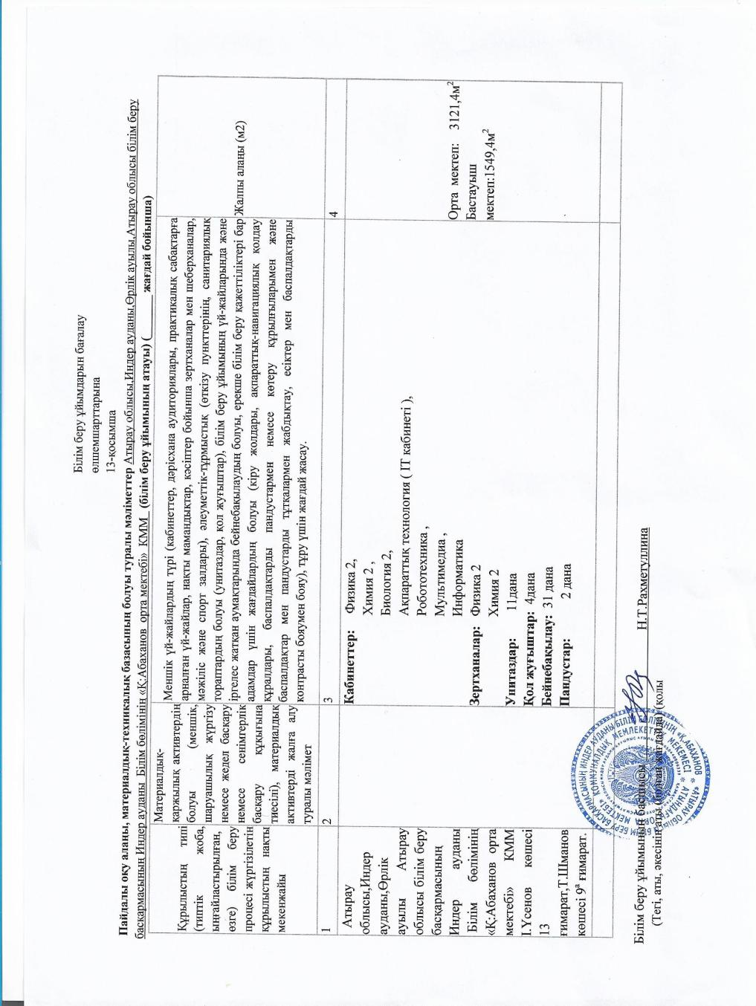

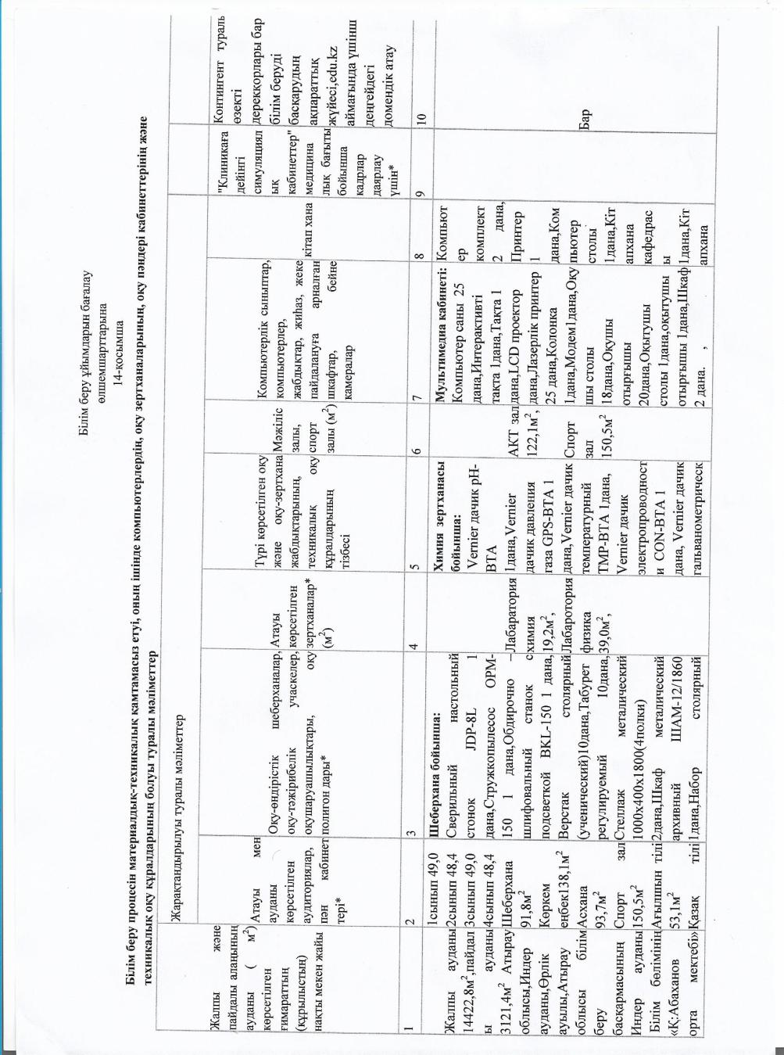

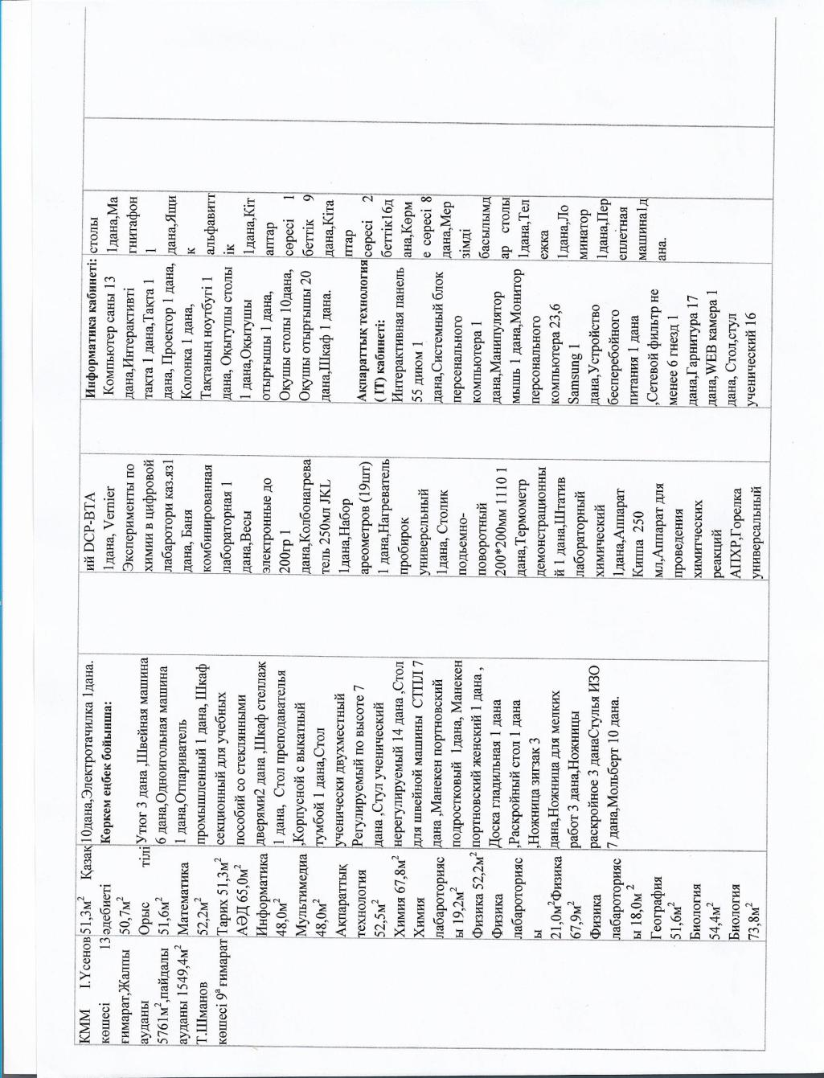

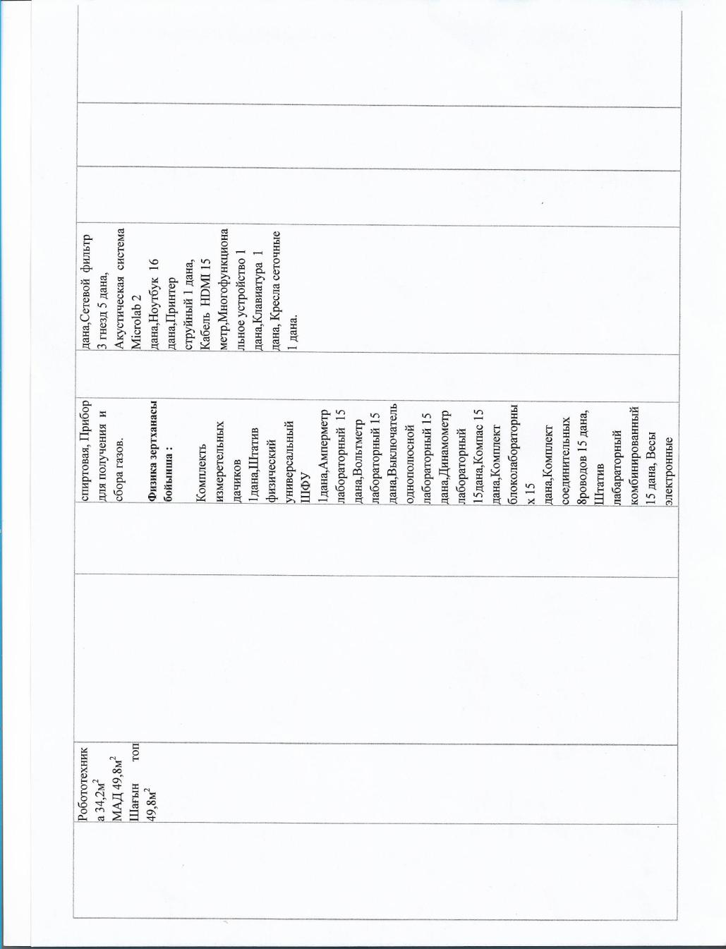

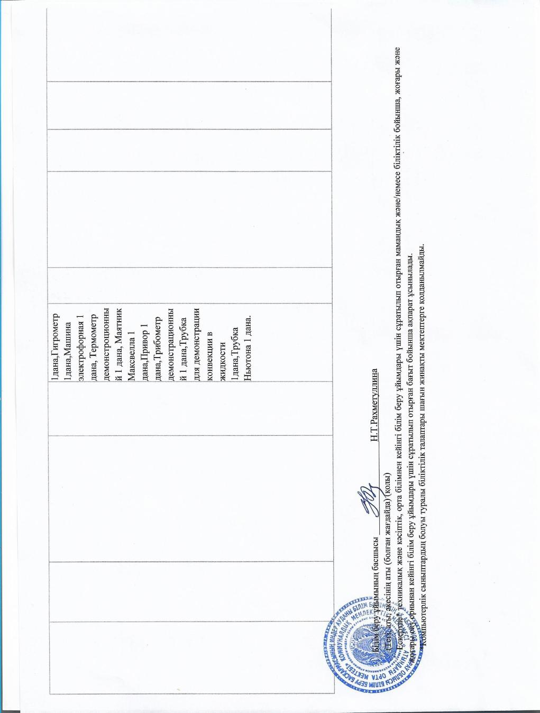

Domain Name............: abakhan.edu.kz

Organization Using Domain Name

Name...................: Rakhmetullina Nurzhamal Tukhbatullaevna

Organization Name......: KGU Srednyaya shkola imeni K.Abakhanova otdela obrazovaniya Inderskogo raiona Upravlenie obrazovaniya Atyrauskoy oblast

Street Address.........: Usenov,13

City...................: Inderskiy raion, s. Orlik,

State..................: 060206

Postal Code............: Atyrauskaya

Country................: KZ

Administrative Contact/Agent

NIC Handle.............: RegKagazgA

Name...................: Kagazgalieva Akmaral

Phone Number...........: +7 702 614 6577 1234

Fax Number.............:

Email Address..........: [maral-7272@mail.ru](https://e.mail.ru/compose?To=maral%2d7272@mail.ru)

Nameserver in listed order

Primary server.........: dns.megaline.kz

Primary ip address.....: 95.56.237.24

Secondary server.......: dns1.megaline.kz

Secondary ip address...: 212.154.163.162

Domain created: 2021-12-24 05:32:10 (GMT+0:00)

Last modified : 2021-12-24 05:33:10 (GMT+0:00)

Domain status : ok - Normal state.

Registar created: NIT.KZ

Current Registar: NIT.KZ​

